**Abstract**

It's been speculated that Social Security benefits will not expense out full entitlement when millennials will need to draw on it.

One idea is that baby boomers have outlived their expectancy and will draw down on Social Security benefits. In an economy where people almost need to have some kind of retirement alternative such as a 401k or IRA, at what age are investors capitalizing the most on individual retirement plans as of 2018?

This article will review retirement background along with a data sample of retirement accounts viewed by age, 2018 contribution amounts, and annual income.

**Introduction**

Changes in retirement programs and ongoing economic, social, and health-care-related trends raise questions about the financial security of those retiring in the future (Johnson, 2017). As Social Security increase their full retirement age it will reduce benefits for workers who retire in the future and the systems long term financing problems could lead to additional benefit cuts in the future (Johnson, 2017).

These changes will lead to people wanting to secure their future by contributing to a personal retirement program such as an IRA.

At what age are investors maximizing their retirement plans? It is understood the earlier the nest egg is built the better it will be once it becomes closer to retirement age. For those that just graduated from a 4-year university or have begun working in their 20s contributing to an IRA for their future might not be something they immediately want to do considering the debt they may have collected while in school.

This article will go over data that was uncovered to see at what age are contributions occurring and at what age we have more investors maximizing their retirement contributions.

This review will analyze if there is a factor with the amount an investor in their 20s contributed compared to a person in their 60s.

With the ongoing and possible change to Social Security benefits does the amount a

person makes affect the amount they contribute or has our future raised such a concern that the amount a person makes does not contribute if they will make IRA contributions? This article will review sample data collected from an investment firm for all IRA accounts and review their annual income in comparison to their contribution amounts. It will analyze if the younger generation is maximizing their contribution limits just as someone closer to retirement would no matter how much income they are making.

**Literature Review**

Half of total private retirement assets are held in IRAs and the growth is driven by rollovers from employer-sponsored retirement plans (Chen, 2017). Traditional IRAs were introduced in 1974 to those that did not have a retirement plan at their employers but by 1981 explained to allow all workers eligibility to contribute. When IRAs expanded to all workers it was primarily utilized by those that made more money. In the analysis of reviewing age with the annual income, it would be concluded that the more money you make the more contribution maximization can be seen.

As a person gets older the more it is realized how much will be needed to retire, pa-contribution care costs, and have a backup plan. Studies have shown that many retirees are so worried about running out of money that they don’t want to touch their savings, even if they have a healthy amount of funds (Block, 2020) In comparison to the analysis those closer to retirement age will almost always contribute maximized limits because they can see retirement fast approaching.

To know if the amount saved is enough the rule of thumb suggests that you will need about 70% of your current income to maintain a current retirement lifestyle (Hebeler, 2018). If this amount does not seem feasible to the number of retirement funds held then a decision to work longer or cut expenses will be needed. This review will want anyone at any age to want to maximize their annual contributions because perhaps current lifestyles are expensive, and they will need a good nest egg to retire at the age they want to retire and not have to work longer or cut expenses.

Retirement is one of the most important financial planning decisions for families and individuals (O’Neill, 2016). The first step for many people is to determine what age they want to retire. The earlier one begins to contribute to their IRA the more likely they will have sufficient retirement funds at the age of retirement. Workers who start saving in their mid-30s can safely set aside about 6% of their income if they work until age 70 but to retire at age 62 the savings needs to be 24% (O’Neill, 2016). Therefore, beginning in the 20s at 6% will only set up that savings nest earlier and allow more flexibility with retirement dates.

**Methodology**

Investments has been my past career for the past 13 years. This study was chosen to see if at any given age are you contributing your maximum to save for the future and does making more money means you will maximize the annual contribution limit. The resources were not available to me to plan and save for the future nor was I taught about the importance of it by my family. The financial area advocates creating an emergency fund and then maximizing your savings contribution for retirement and it is the basic advice given no matter the age. The hypothesis I predicted before gathering the data was that around age 30 is when we would see an increase in maximized contributions. It is when an investor has already been in the workforce for a couple of years and would have heard the importance of saving for the future. It is also the time when investors start having families and are concerned for their future and making choices and reviewing retirement. In addition, the more money that one makes the more likely one will maximize contributions limits.

This data does not include if they have retirement plans elsewhere that they are also contributing to. With the R2 at 13%, there is a lot of room for error which will be all the reasons that factor age with contribution amounts and income. Other factors that could contribute are if they are married with a family, have accounts elsewhere that they are contributing, or if the data they provided in the application has changed such as income since they 1st provided us the information.

**Data**

The independent variable of x used was age. The dependent variable of y was annual income and contribution amounts. The graphs below represent the relationship between x and y by scatter diagram models in a linear function.

Graph A

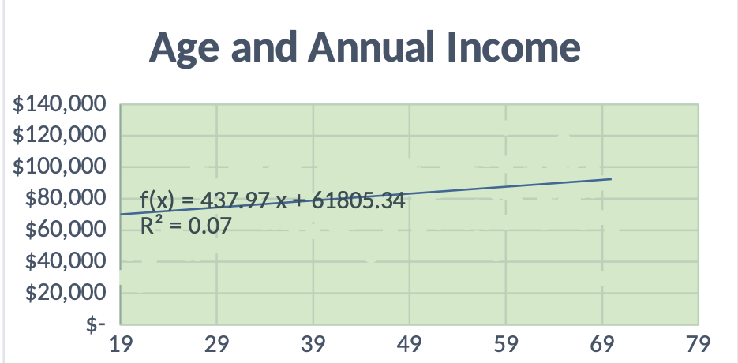

Graph B

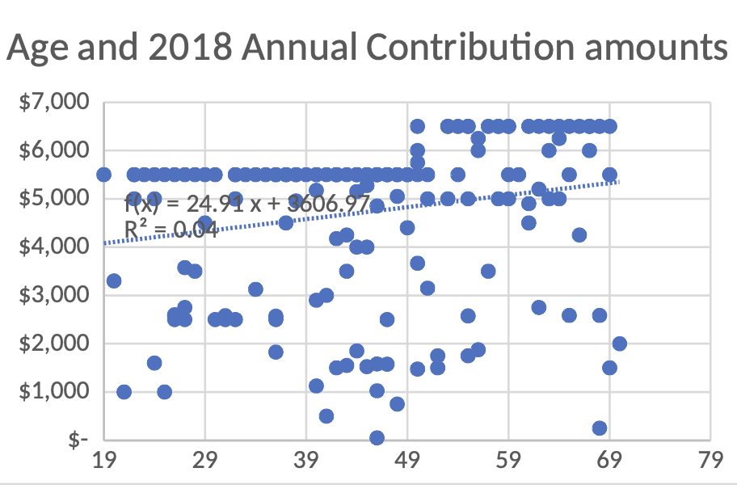

The tables below reflect the statistical multiple linear regression function utilizing the data analysis function on excel. Using the regression tool to estimate the multiple linear regression function by OLS for our age sample.

Table 1

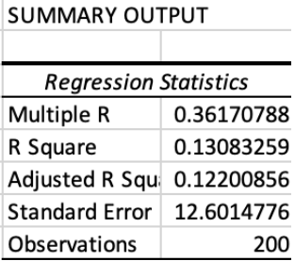

Table 2

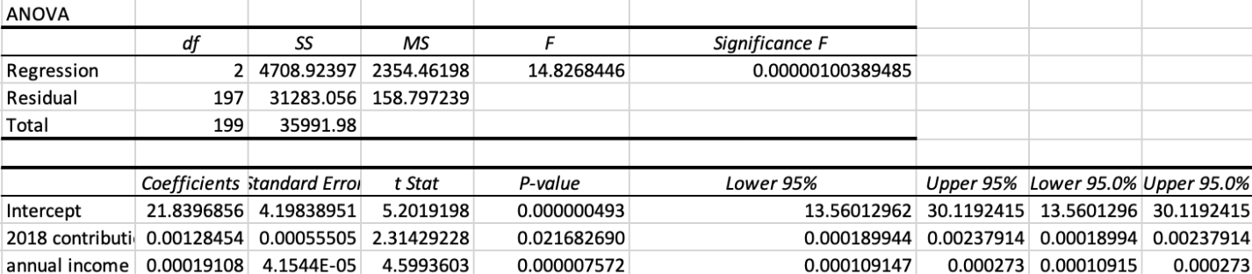

**Results**

The linear relationship between the one dependent variable of age (y) and the two independent variables of x1 annual income and x2 contribution amount can be seen as:

y = B0 +B1x1 + B2x2 + e. According to table 1, only 13% of the variation of (y) age is explained by income and total 2018 IRA contribution total for (x) which is shown as R2.

Annual Income and total IRA contributions both have a positive linear relationship but according to graphs A and B, it is visible that annual income has more of a positive relationship than annual income. Graph B shows a regression model of no relationship as all ages were maximizing contribution limits. Both graphs reflect a visual depiction of neither Heteroskedasticity nor Homoskedasticity as the scatter graphs do not show a close relationship nor a funnel-shaped relationship. Utilizing table 2 and the coefficients it is estimated that the sample regression function is Age = 21.83 +.0012 IRA contribution amount + .00019annual income.

After testing the hypothesis, the data reflects as H0: B1 = 0, therefore it has no linear relationship between x and y and we reject Ho since it is not within the confidence level and conclude that annual income and amounts contributed per year are not affected by someone’s age.

Age-to-annual contribution limits have a worse fit to the sample data as the scatter plots are not closely related to the linear line. This describes the observed data and is measured by R2 and the standard error of the regression.

**Conclusion**

Age was not a factor in IRA contributions and the amount an investor made in income. One idea that was thought about was that the investment firm primarily has a military background with its members and the military might have been given information about saving in an IRA. Some changes I would have made would be adding more variables such as education level or if the investor was married or single. Adding more variables would have allowed having more coefficients and would have perhaps allowed the R2 to increase by having more data. As I self-reflect on the project, I would have liked to understand the topics of econometrics in more detail as I felt that 8 weeks was not ample time to get a full understanding. This analysis was difficult when I began with questions about my data, but it became more clear as I utilized the key topics I learned from this class.

**References**

Block, S. (2020). Plan Now to Retire Worry-Free. (Cover story). *Kiplinger’s Personal Finance*, *74*(2), 44–51

Chen, A., & Munnell, A. H. (2017). Who contributes to individual retirement accounts? *The issue, in Brief, 17-8*

Hebeler, H. (2018) Make Sure You’re Saving Enough. (2018). *Kiplinger’s Personal Finance*, 18-21

Johnson, R. W., Smith, K. E., Cosic, D., & Wang, C. X. (2017). Retirement prospects for the, *17*.

O'Neill, B., AFC, C., CFEd, C. F. C. S., Gutter, M., Head, L. S. W., & Kiss, D. E (2016). How do people make retirement decisions? Yilan Xu, Ph. D.